**PICTO THEQUE V2**

Pictoteque is web application developed like an e-commerce website having picto(icon) displayed in the central area, shopping cart and favorite. This application is used by the PSA Graphical user for the designing purpose in the Automobile industry.

Pictoteque web application divided in 3 part

Header, Central and Right part

Information Area

Menu Area

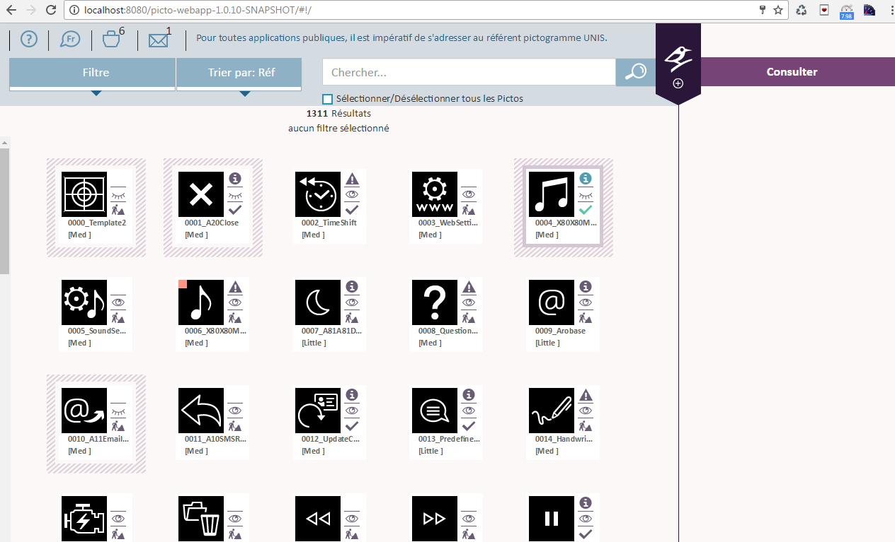

Central Area

**Menu Area**: This contains different menu and functionality, it’s given below

**Notice/Help**: Its contains the documentation of picto web application, user click on image it open new window display its content.

**Language**: User can select French or English language. By defaults its French.

S**hopping Cart:** It contains number pictos added in the cart. On click on the basket display the items added in the cart.

**Modification Contributor(Message):** The number of pictos updated by the contributor, its notification is display in the message box. This notification is visible only for Admin. Admin can view the changes made by the contributor and validate the picto.

**Search Box:** Add the text and search, list of pictos displayed on the central area.

**Sort :** Sort the thumbnail displayed on central area based on Reference Number , Ref Charte, Date (Modification date).

**Select/Deselect All:** Based on the check box value, the Central area pictos are selected or deselected.

**Filter:** Based on the selection check box in filter area, pictos are displayed in Central area.

Filtering of data can be done by

* Categories
* Validation Level
* Information
* Filter date
* Favorite
* Visibility
* AI Working File: Visible only to Admin profile.

Filter by defaults: Clear all the check box which is already selected to filtering the data.

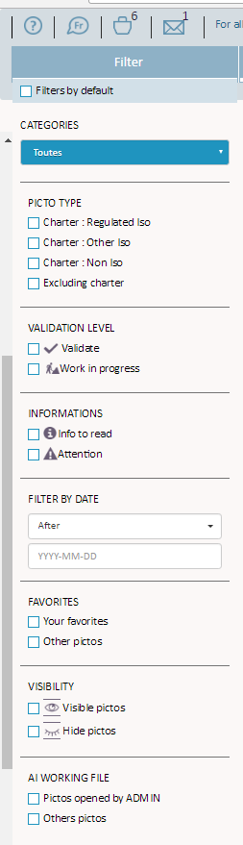

**Central Area:**

Display first 100 pictos in the central area, based on the scroll load other pictos having the frontage value is true. On single click the icons, its gets selected and tool box get displayed. Based on the selection of icon, thumbnail tool box (Favorite, Shopping cart, Download) gets activated and contents of particular picto is been shown on information area.

It’s composed by 4 areas:

1. Thumbnail
2. Thumbnail tools box
3. Thumbnail news box
4. Thumbnail name(Reference number + ref charte+name + variants)

C

A

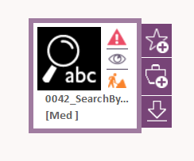

D

B

**Thumbnail news Box:** Its divided by 3 areas

* Information Type
* Visibility
* Validation Level

Information Type: Information of the pictos displayed on the screen based on the values

* None: Nothing will display.
* Info: Information symbol
* Warning: Warning symbol

Visibility: Divided in 2 area

* Visible: The Icon will visible to all profiles (Admin, contributor, user)
* In Visible: Only for admin.

Validation Level: Divided in 2 areas and based on the value images are been display.

* Valid
* Work in progress

**Thumbnail tools box:** Its contains 3 links

* Favorite
* Shopping Cart
* Download

**Favorite:** Click on button add the picto and  remove the picto from favorites.

**Shopping Cart** : Click on  add the picto and remove the picto from cart.

**Download**: Click on the download button() the download window open in UI user can select the file format , variants and click on download link the images get downloaded from server path to UI in zip format.

By default, variants check box selected based on the picto variant which is been downloaded from the UI.

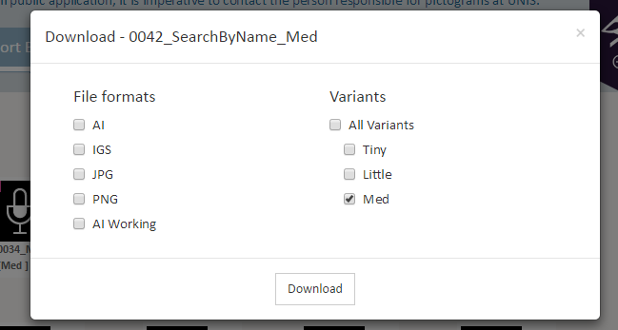

**Information area**: Information particular picto is displayed on the right side UI.

Top right corner of the UI having below links

Validate

Export PDF

Delete

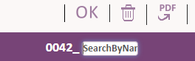

Name of Picto

Validate: The content of picto edited in the information area is saved in the database on click of OK.

Delete : Admin can Delete picto family by click on ()button. Delete the data from DB and images /folder from the server path.

Export PDF: Generate the PDF for the picto information.

Notifications are editable by admin and read only to contributor and user profile

Admin Info: Only visible and editable by admin profile.

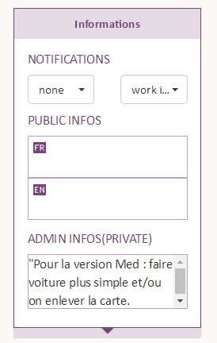

Admin Information

Information Type

Validation

Public Information

**Frontage and variants**:The picto family having multiple pictos with different variant type and family having one frontage picto which display in the Central area. The remaining pictos displayed in the variant block.

Admin can update the variant to frontage by click on () ,delete by () and need to validate by “OK” button.

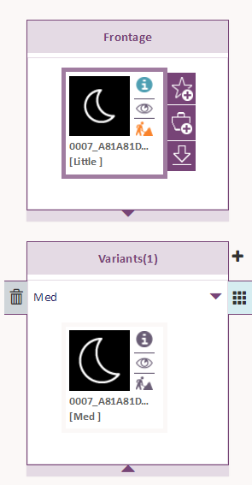

Delete Variant

Make Frontage

Create Variant

**Creation of Variant:** Variant can be create by click on (), it will open new window as shown below.

Upload Picto: Choose the file from directory, it should be .ai format.

Select variants from drop down and version (not mandatory) and click on create.

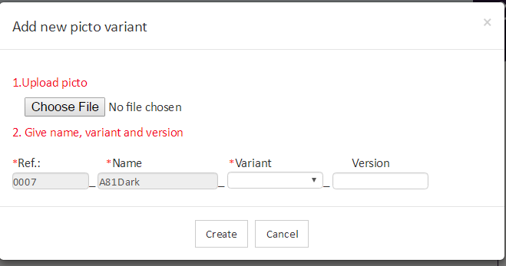

**Specific Drawing:** Admin can create and delete the specific drawing information. On click of specific drawing the images get downloaded in UI.

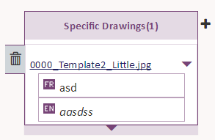

Create Specific Drawing:

Choose the file from directory of any format and add the comments in section FR and EN and press create.

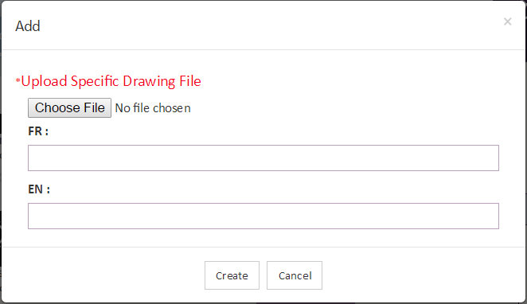

**Usage**: This section only editable by Admin and contributor profile and read only for user.

**Function**: Able to add french and English function in text area.

**Type**: Select the type from the drop down values. For the Icontheque type Ref.charte, Command and Telltale, RHN Information and Regulation are hidden.

Ref charte, command and Telltale and RHN information editable by admin and contributor profile.

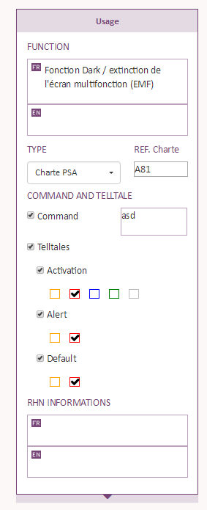

**Regulation:** Rules for the picto family can create and delete by admin and contributor profile. Click on rule name, open new tab with rules information.

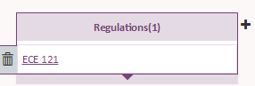

Creation of Regulation:

Need to add the Name and URL in text box and click on Create button.

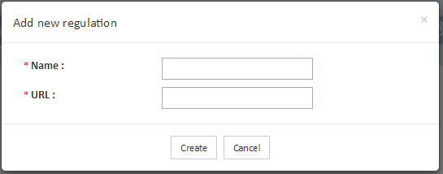

**Tags**:This section dived in 2 area

* Keywords: Add the keyword in French and English text area.
* Categories: Select the category name from the drop down for the picto family.

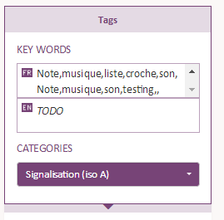

**Shopping Cart:**

Cart view divide in 2 parts:

* Central Cart Area
* Information Cart Area

**Central Cart Area:** The pictos added to cart from the main UI are display. The other functionality is same as Main UI central area.

**Information Cart Area:** Click on picto from cart area, display the information in cart information area and other functionality is same as main UI information area.

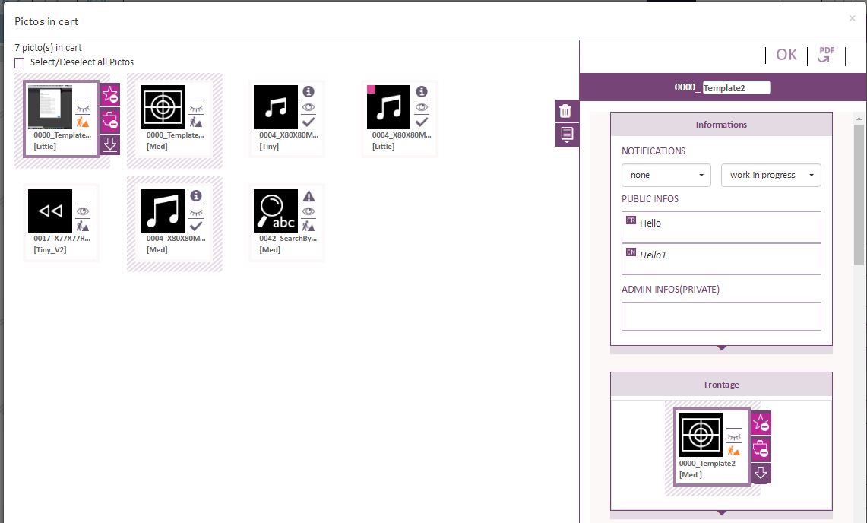

**Import to cart:** Click on button () open new window to browse the file and add the valid pictos to cart. File should be in .txt format. (Ex: 0264, ParkPOI, Little)

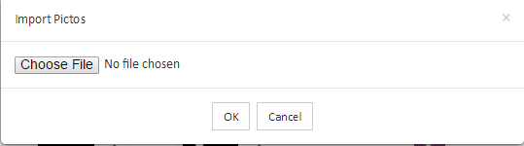

**Download AI work File**: Double click on thumbnail in Central/information area, system checks admin installed thick client in administrator computer. System check if AI working file is already downloaded in the local directory and also display the number of administrator working of this file.

If administrator want to continue, it will open new window.

Open DB version and validate the AI working file get downloaded in local directory. Then administrator can open the file in illustrator.

Abort will cancel the transaction.

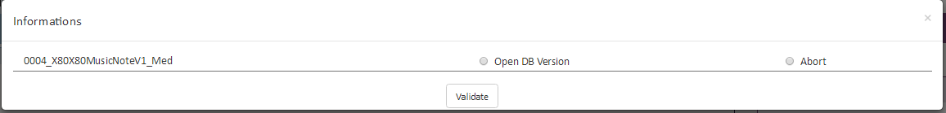

**Create PICTO:**

1. Click on (+), system checks admin installed thick client in administrator computer.
2. Display the creation window in information area.
3. Upload the .ai file and fill all mandatory fields (name, version, information type, validation level, visibility, type, keywords and category) and validate.

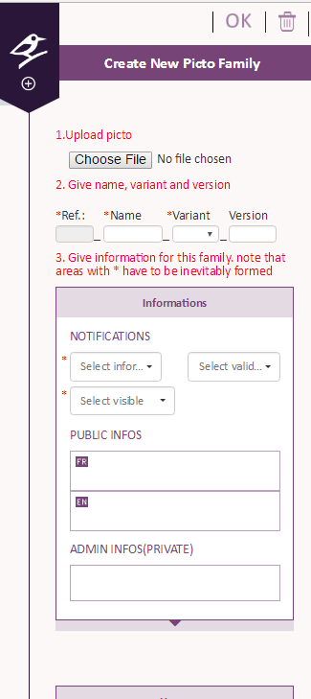

Create Picto

**Multi selection:** User make a CTRL+left click on the thumbnail on different thumbnail, the information area gets empty and multi selection tool box get displayed.



Favorite Add/Remove

Download AI work File

Export PDF

Download

Cart Add/Remove

**ERR Diagram:**



**Picto Directory Path**: Images stored in folder as show in below structure

